**DATA ANALYST PROJECT**

Customer Satisfaction Prediction

Data Set:  
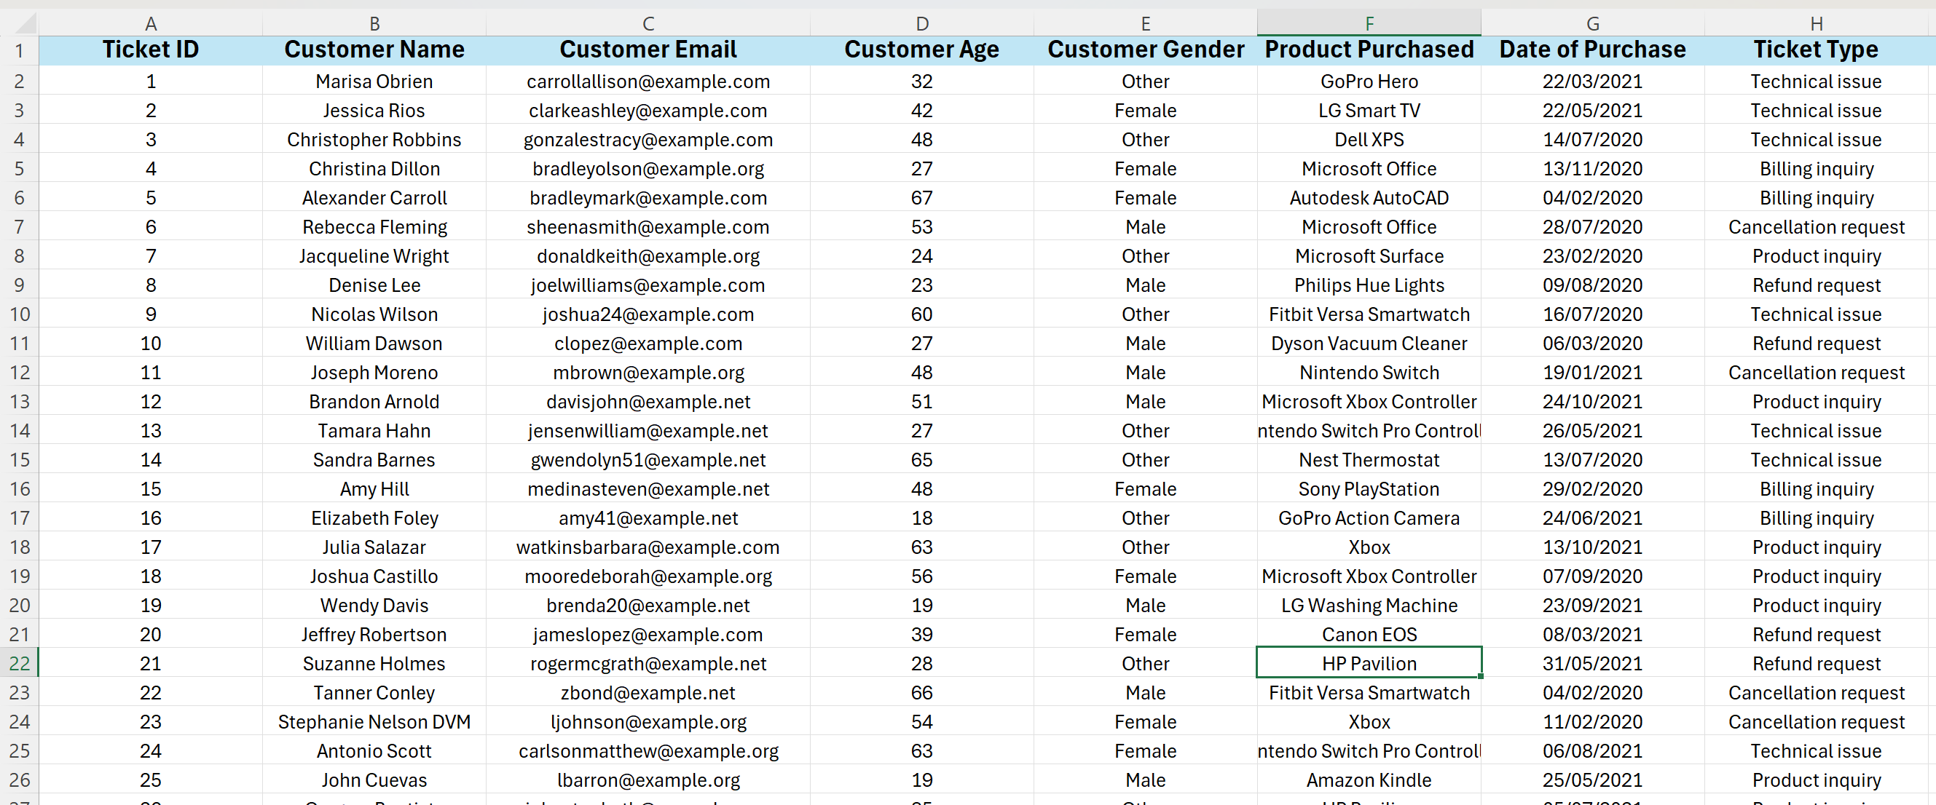

1)Importing python libraries and setting the pandas options up to 17 columns:

import numpy as np

import pandas as pd

import matplotlib.pyplot as plt

import seaborn as sns

import warnings

warnings.filterwarnings('ignore')

#setting pandas options(maximum coloumns options)

pd.set_option('display.max_columns', 17)

2) Checking for null values:

df.isnull().sum()

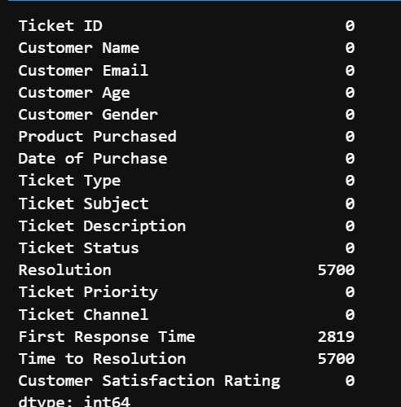

This shows that Resolution, Ticket Response time and Time to Resolution has null values and need to be handled.

3) Checking duplicate values

df.duplicated().sum()

This shows that the data has no duplicate values in the data set.

4) Filling the null values with the forward fill method

df['First Response Time'].fillna(method='ffill', inplace=True)

5) Pie chart on distribution of Customers based on their gender

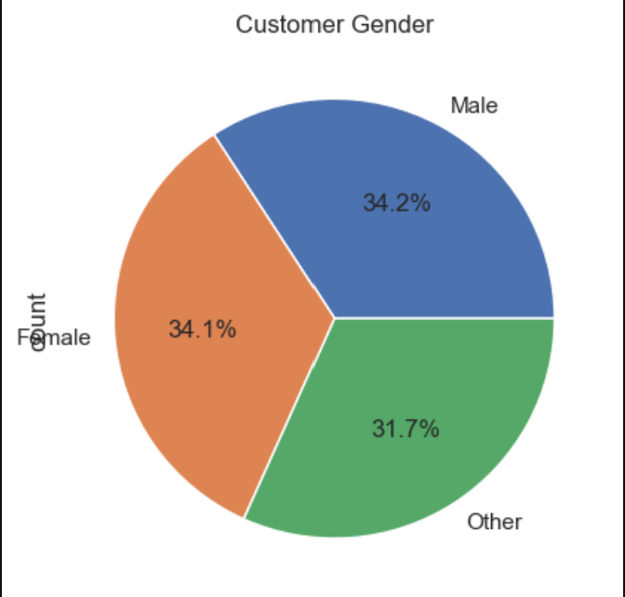  
We have equal number of females and males as shown in the diagram apart from the others who haven’t mentioned  
  
6) Representation of Products purchased

This shows the distribution of each product purchased with the most purchased being the Canon EOS and the least is LG OLED

7) Distribution of Customer age

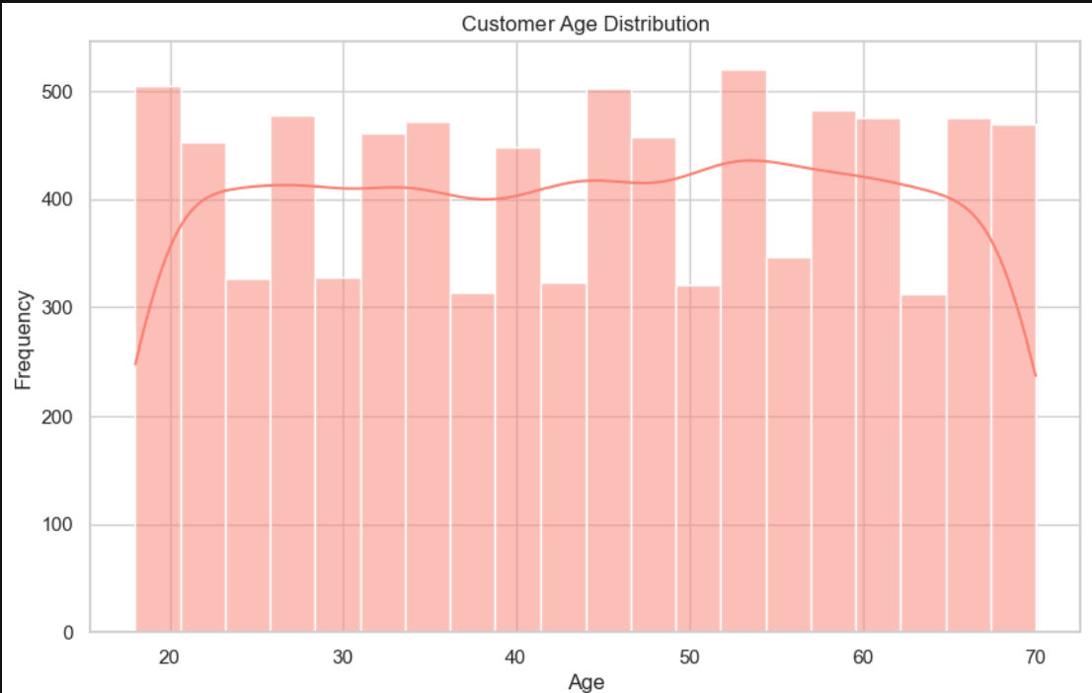

As we see the ages are distributed more or less from the ages of 20 to 70

8) Percentage of products purchased by customers

9) Distribution of Tickets raised by media

We have a equal distribution of tickets raised by the customers with 25% form each media.

10) Ticket Channel distribution

11) Ticket priority

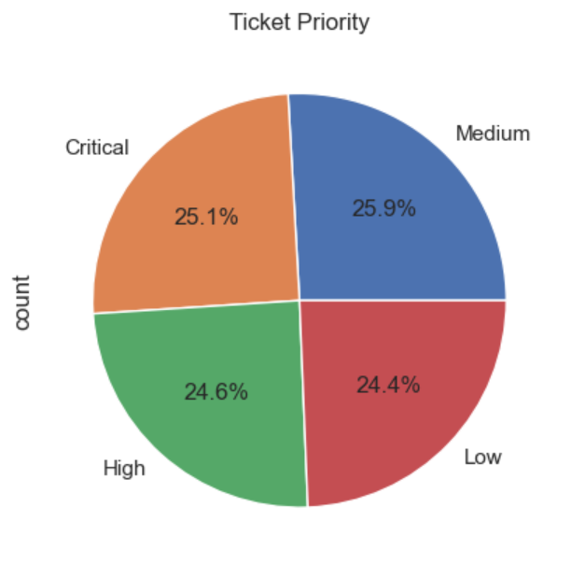

Tickets are either critical or medium priority mostly

12) Customer support ticket trends over time

13) Rating of Customer satisfaction trend

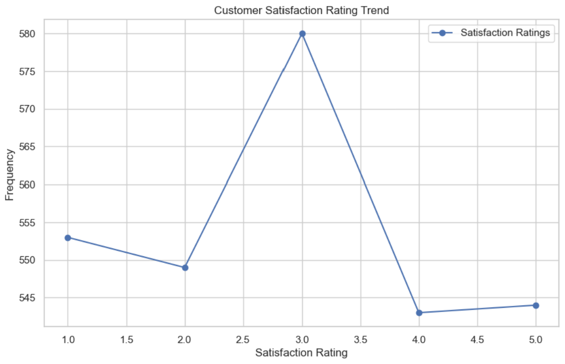

14) Top items purchased based on gender

15) Tickets raised by different age groups

16) Distribution of tickets by age

17) Top 10 Feature Importances

